Publication of West Java Leaders’ Activities on Instagram @biroadpimjabar In an Effort to Implement Good Governance

**Diwan Setiawan1, Achwan Noorlistyo Adi 2, Centurion Chandratama Priyatna3, Eny Ratnasari4**

1,2 Universitas Informatika dan Bisnis Indonesia, Indonesia

3Universitas Padjadjaran, Indonesia

4Universitas Tidar, Indonesia

Email: diwansetiawan@unibi.ac.id1, chwannoorlistyo@unibi.ac.id2, centurion.priyatna@unpad.ac.id3, enyratnasari@untidar.ac.id4

***Abstract:*** *Good governance is a necessity in running the government. The West Java government has made various efforts to implement good governance, one of which is the publication of leaders’ activities on Instagram @biroadpimjabar. The publication aims to raise awareness among the people of West Java by sharing informative and educational content about the activities of West Java leaders and their internal teams, as well as some useful information about West Java. The main purpose of this research is to explore how information about leaders' activities is Share, Optimize, Manage, and Engage as the concept of The Circular Model of SOME by Regina Luttrell. The method used in this research is qualitative. Data was collected through observation and in-depth interviews. The results showed that at the Share stage, the shared content of the leader's activities showed transparency so that it could build public trust. In the Optomize stage, the leader uses interesting video content and informative captions. In the Manage stage, a third application is used to monitor the performance of social media to evaluate its activation. The last stage is Engage, for interaction and community involvement in the form of comments and direct messages, even more followers want to conduct audience activities with West Java leaders after learning about the @biroadpimjabar account. These findings provide recommendations for improving public communication strategies to strengthen the implementation of good governance in West Java.*

***Keywords:*** *good governance; instagram; social media; the circular model of some; west java leadership administration*

# INTRODUCTION

Various efforts to improve public services in accordance with the concept of good governance are carried out by the government in various ways. One of them is by using e-government systems, websites and social media (Hutagalung, 2016). Since 2003, the Indonesian government has been advised to adopt an e-Government system as outlined in Presidential Instruction Number 3 of 2003 concerning National Policy and Strategy. Governance reform is supported by the use of e-Government. The purpose of e- Government is to improve public interaction by utilizing technology to provide websites, applications, email, and other computing digital services. Based on the results of previous research, a high-quality government website can increase the credibility of the government website (Nainggolan, 2024a).

The role of online media such as websites and social media is considered as a means of transparency of government information, soliciting public input, encouraging public participation and enhancing collaboration within government as well as between the public and private sectors, adding that such efforts can ensure public trust and strengthen democratic values as well as operational effectiveness and efficiency (Armstrong, 2011; Lisdawati, 2022; Nainggolan, 2024b). The effectiveness of e-government is not only focused on the benefits for the government in receiving ease of communication to the public and facilitating the government in articulating goals, but also focuses on the extent to which the use of social media can increase public trust and community participation (Rahmanto, 2022a).

Since the use of online media in public services, public trust in the government has tended to increase. Increasingly sophisticated communication technology is one of the factors for government public communication to be carried out online. Government transparency can be created by conducting innovative communication and can encourage the public to participate in the government's decision-making process (Abdelsalam et al., 2013; Porumbescu, 2016; Srisathan et al., 2024).

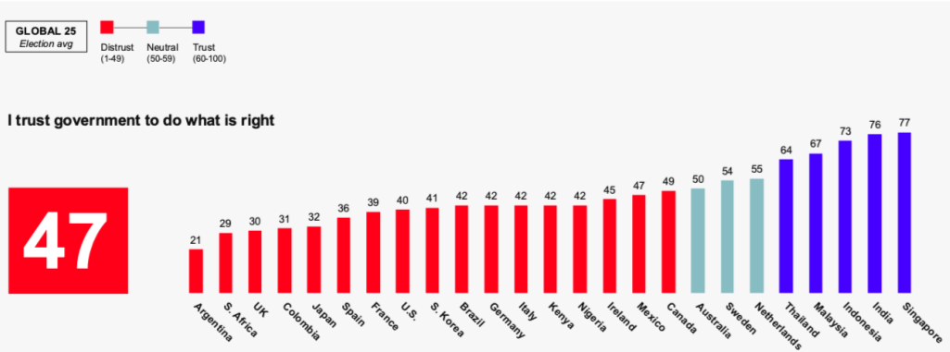

***Figure 1****. Score of Public Trust in Government Source: (Edelman Trust Barometer, 2024)*

Based on the data shown in Figure 1, the Indonesian people's trust in the Indonesian government throughout 2023 is at 73% and puts Indonesia in third place globally in terms of the level of public trust in its government. Public trust in the government is also influenced by massive public communication factors, which are carried out by the government through various communication channels, one of which is social media.

Social media has a strong correlation with the public sector, especially in terms of public policy. Social media has also become a medium of communication between policy makers and actors with the public, where the public can convey their expressions and opinions on a policy implemented (Hutagalung, 2016). The presence of social media has driven the bureaucratic reform process (Huda & Yunas, 2016). This makes the distance between the government and the public shorter, more transparent and responsive. In addition, social media is increasingly important to be used by the government because social media is based on the connectedness of users through direct communication who share information, opinions, and ideas, government-citizen communication through social media has a greater chance of being interactive (Matheus et al., 2023). In other words, these conditions encourage strengthening the creation of good governance in government.

The publication of the activities of West Java leaders, in this case the Governor, Deputy Governor, and Regional Secretary, on Instagram @biroadpimjabar is one of the efforts to implement good governance carried out by West Java leaders. Initially, @biroadpimjabar aimed to publicize the activities of the team behind the scenes of activities carried out by the leaders of West Java, but due to the high insight and positive response from the community, finally the management of social media @biroadpimjabar also focused on preparation activities to the implementation of the activities of the leaders of West Java. (Asri, 2024).

Biro Adpim Jabar is a fragment of the Public Relations and Protocol of the West Java Provincial Government. The role and function of Public Relations of West Java Province was handed over to the Communication and Information Service of West Java Province, while the duties and functions of protocol changed its name to the West Java Leaders Administration Bureau (Biro Adpim Jabar). This is based on Permendagri No.56 of 2019 concerning Nomenclature and Work Units of the Provincial and Regency / City Regional Secretariat, in Article 4 Paragraphs (1) and (2) which reads “The type A provincial regional secretariat, consists of at most 3 (three) assistants” and “The assistant as referred to in paragraph (1) consists of 3 (three) bureaus. Then in Article 8 Paragraph

(3) letter a, the Bureau of Leadership Administration becomes one of the Bureaus in the General Administration Assistant of the type A provincial Regional Secretariat (Kementerian Dalam Negeri Republik Indonesia, 2019)

The main tasks of the Bureau of Chief Administration are to organize the preparation of general policies, coordinate administration related to the implementation of tasks in various parts of the regional government, and provide administrative services related to chief administrative affairs. But not limited to household management, leadership communication materials, and protocol procedures which are the authority of the provincial government. The West Java Adpim Bureau is also responsible for carrying out deconcentration tasks up to the formation of the Governor's Secretariat as a representative of the Central Government, and carrying out assistance in its field of duties in accordance with applicable regulations (Biro Adpim Jabar, 2021). This means that the West Java Adpim Bureau has a role and is responsible for the administrative affairs of the West Java Leaders consisting of the Governor, Deputy Governor, and Regional Secretary and also indirectly has a role in the regional government of West Java..

The West Java Adpim Bureau itself has had several achievements such as the “Top Innovative Finalist for West Java in 2021 with the Title of JAPRI (West Java Has Information) Innovation”, the “FYP of the Year Humas Jabar Awards 2023” award and the award to the Head of Administration of the West Java Adpim Bureau as “Role Model Secretary of the Year Humas Jabar Awards 2023”. Since it was still called the Bureau of Public Relations and Protocol, this bureau has also obtained various achievements. Starting from the “Top 10 West Java Innovation Competition 2020: Title of JQR (Jabar Quick Response) Application”, bringing the West Java Provincial Government as ‘Top 30 Government Agencies Organizing Public Service Complaints’, to achieving ‘5th Place in the Provincial Government Category of the Central Information Commission’ (Interview With Berau Adpim Team, Asri, 2024).

The many variations and types of social media platforms that have emerged affect the communication characteristics of their users. Zhu and Chen developed a typology based on two characteristics of social media, namely the nature of connections (profile- based versus content-based) and the degree of message customization (the extent to which services are tailored to meet individual needs for specific preferences) (Voorveld et al., 2018).

There are four categories of social media based on the above two characteristics, namely: (1) Relationship, representing social media platforms that are profile-based and consist mainly of customized messages. This category includes social media platforms such as Facebook and LinkedIn; (2) Self-media, representing social media platforms that are profile-based but offer users the opportunity to manage their own social media communication channels, e.g. Twitter; (3) Creative out-late, representing social media platforms that are content-based and allow users to share their interests and creativity, e.g. Youtube, Instagram and TikTok; and (4) Collaboration, representing platforms that are content-based but allow people to ask questions, get advice, or discover the most interesting news and content at the time (Rahmanto, 2022b; Voorveld et al., 2018).

Some of the social media owned by the West Java Adpim Bureau include Instagram, X (Twitter), TikTok, and YouTube. The selection of social media as a public communication media carried out by the West Java Adpim Bureau is the right choice in the current era because social media has the potential to expand government services, increase public participation, gather innovative thoughts from the public, and improve decision making and problem solving (Bertot et al., 2012; Sukarno & Winarsih, 2021; Yuliani et al., 2020). Social media also provides various opportunities for the government to interact with the wider community (Diga & Kelleher, 2009; Sukarno & Winarsih, 2021). The use of social media based on Web 2.0 technology is very useful for self- expression and citizen participation in government activities and can be used by the government to increase citizen participation (Dwivedi et al., 2017).

Of the many social media used by the West Java Adpim Bureau, Instagram is the social media that is used optimally. The selection of Instagram itself is a strategic effort made by the West Java Adpim Bureau to publicize the activities of the West Java Leaders. This is certainly inseparable from the trend and popularity of Instagram among the many existing social media. Data from We Are Social also says that in Indonesia Instagram is ranked as the second most favorite social media.

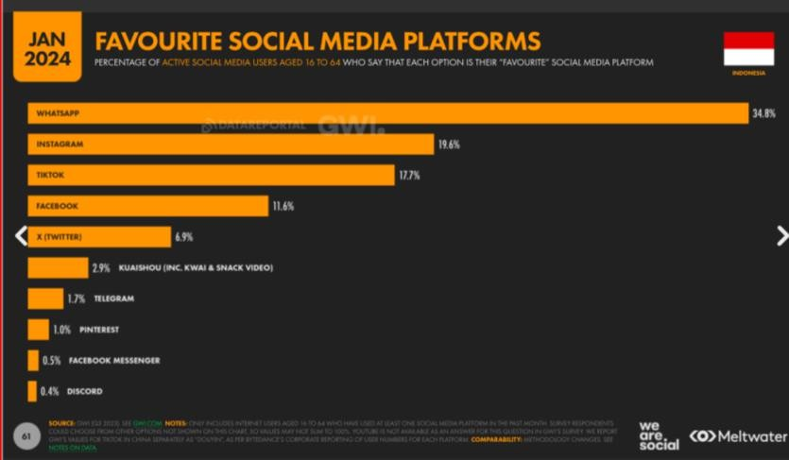

***Figure 2.*** *Favourite Social Media Platforms in Indonesia 2024 Soucre: (We Are Social, 2024)*

The popularity of Instagram in Indonesia is inseparable from its many users. Data from We Are Social states that Instagram users in Indonesia reach 85.3% of the total population of social media users in Indonesia which reaches 139 million. This means that there are around 118,567,000 social media users in Indonesia using Instagram as their social media.

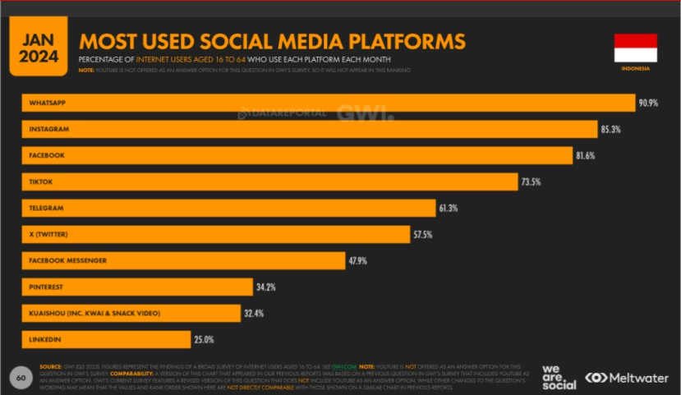

***Figure 3****. Most used Social Media Platforms in Indonesia 2024 Source: (We Are Social, 2024)*

Of course, in managing social media carried out by the West Java Adpim Bureau, especially to publicize the activities of its leaders, the West Java Adpim Bureau uses a social media planning strategy. Social media planning for public relations activities has been outlined by Regina Luttrell by creating a model that can be used as the main component in social media research and planning. The model is called The Circular Model of SoMe which consists of Share, Optimize, Manage and Engage (Luttrell, 2021). This model can serve as a means for social media practitioners to communicate and interact on social media platforms. This model involves four stage elements, each of which has an important role in its own contribution. Starting from the Share stage or sharing information. At this stage practitioners publish useful content, spreading messages through targeted platforms can build trust and awareness. Then the Optimize stage, at this stage a strong communication plan and optimizing content can produce maximum message, brand, and value impact. Next is the Manage stage, where at this stage social media managers manage, monitor, and measure messages to ensure their relevance. Finally, the Engage stage where there is direct interaction and engagement with the intended audience (Alexander et al., 2022; Luttrell, 2021; Qurniawati et al., 2024).

For this reason, in this research, The Circular of SoMe model is used as a reference to understand and analyze the social media management strategy used by the West Java Adpim Bureau to publish the activities of the West Java Leaders in an effort to implement good governance. This model is used because it is considered a framework that can provide in-depth and structural insights into the principles and strategic steps involved in social media management efforts by the West Java Adpim Bureau.

# METHODS

This study used the qualitative research method. Qualitative research intends to describe the form of words and language, in a special natural context and by utilizing various natural methods. Qualitative research produces descriptive data, for example, speech, behavior, or writing derived from observed research subjects (Hadi et al., 2021). The subjects in this study consist of one (1) informant chosen through purposive sampling. The informant is the person in charge of social media from the West Java Leadership Administration Bureau with the position as a young expert policy analyst (Analis Kebijakan Ahli Muda).

Data collection was carried out through interviews, observation, and documentation. The interview used is a structured interview. Structured interviews are used as a data collection technique if researchers or data collectors know with certainty about what information will be obtained (Sugiyono, 2017), researchers used non- participant observation, which means the observer does not take part in the observatory’s life (Hadi et al., 2021), researchers observe through insights, likes, and comments or engagement contained in Instagram @biroadpimjabar, and after the data is collected, researchers test data validity using data sources triangulation. We check the performance of Instagram @biroadpimjabar through the social blade website. The data analysis technique conducted in this study is according to Miles and Huberman, where the activity is carried out interactively and continues to completion to completion, ranging from data reduction, data presentation, and finally grouping data to get conclusions.

# FINDINGS AND DISCUSSION

The implementation of sharing in the Instagram account @biroadpimjabar is by sharing the content of leadership activities in all features owned by Instagram, such as feed, story, highlight, and reel. Content related to leadership activities is intended to show the government's transparency. In addition, this content aims to build public trust.

In the sharing stage, it can also be seen from the availability of profile pictures relevant to the content shared by the @biroadpimjabar account. This account uses a logo and typography to explain that this account belongs to the West Java Provincial Secretariat Administration Bureau.

**Table 1.** Categorization of Communication Activity Based on The Circular Model of SOME

|  |  |  |
| --- | --- | --- |
| No | Dimension | Indicator |
| 1 | Share | 1. Relevant profile picture 2. Bio caption has explained account content with not exceed 150 character 3. Provide link website |
| 2 | Optimize | 1. Content relevance 2. Frequency of post |
| 3 | Manage | 1. Interaction with audiences 2. Reply comment |
| 4 | Engagement | 1. There is CTA (Call to Action) 2. The use of appropriate hashtag |

**Table 2.** Results of content analysis on the @biroadpimjabar account

|  |  |  |  |  |  |
| --- | --- | --- | --- | --- | --- |
| No | | | Element | Finding | |
| 1 | | | Relevant content | Content based on audience research and suit to the leader | |
| 2 | | | Post frequency | Content is uploaded according to the results of social media monitoring. So that posts are in accordance with the prime time hours owned by the account | |
| 3 | Use appropriate hashtag | | | In each post using hashtags, the hashtags used are adjusted to the content, such as #AdpimOnDuty |
| 4 | Interaction with audience | | | This account rarely interact with audience |
| 5 | Reply to comments | | | This account rarely reply to comments |
| 6 | Call to action content | | | Accounts often use the call to action formula |
| 7 | Profile picture | | | Profile picture has represented the purpose of the account |
| 8 | Account bio represents the purpose of the account | | | The account bio clearly explains who owns this account |
| 9 | Account bio not exceed 150 characters | | | The biodata on the account clearly explains the account owner, accompanied by a tagline, tags on sister accounts |
| 10 | Provide link website | | | This account provide link to their website on their bio. Link on the bio updated regularly according to the program being run by them |

The availability of a bio in the @biroadpimjabar account also represents the intent of this account, as shown in Figure 4a. In the Instagram bio, it says West Java Provincial Secretariat Administration Bureau. This account chooses to represent itself as a Government Official. In addition, the account also says "Behind-the-scenes team," "Governor, Deputy Governor, and West Java Regional Secretary." The bio also explains the sections within the West Java Provincial Secretariat Administration Bureau, namely the protocol, communication, and household teams. Finally, this account mentions another account, @westjavagov_, as a sister account of this account.

The @biroadpimjabar account also includes a link explaining its purpose, as seen in Figure 1b. The links in the Instagram bio include the West Java Leadership Administration Bureau service (Figure 5a), the West Java Leadership Administration Bureau website (Figure 5b), and the 2024 West Java Youth Forum Registration (Figure 5c).

|  |  |
| --- | --- |
|  |  |
| (a) | (b) |

***Figure 4.*** *@biroadpimjabar Instagram Account (a); Link in the @biroadpimjabar Instagram bio*

*Source:* [*www.instagram.com/biroadpimjabar*](http://www.instagram.com/biroadpimjabar)

|  |  |  |
| --- | --- | --- |
|  |  |  |
| (a) | (b) | (c) |

***Figure 5****. View of the page in the Instagram bio @biroadpimjabar: West Java Leadership Administration Bureau Services (a), West Java Leadership Administration Bureau website (b), West Java Youth Forum 2024 registration page (c)*

*Source:* [*www.instagram.com/biroadpimjabar*](http://www.instagram.com/biroadpimjabar)

At this stage, Luttrell emphasized three crucial things: participate, connect, and build trust (Luttrell, 2018). These three things mean that an agency that manages social media must provide the information it wants to convey where social media activation is not arbitrary. Only social media should have a high share value so that the relationship between the agency and its public can build trust. However, before activating social media, it is essential to understand the characteristics of each social media by understanding the value of social media and who the target will be.

The optimization stage is carried out in the Instagram account @biroadpimjabar by creating a social media content management strategy; namely, the content style is adjusted to the leader's character. The previous leadership was known for entertaining content, while the current leadership chose to make informative content. This account creates more informative content based on audience research, remains entertaining, and follows the trend. So, they use exciting video content and informative captions.

Researchers found that @biroadpimjabar increases content in reel format. This is because they realize that by creating Instagram algorithm content. The upload time of the content depends on the needs. Some uploads must be uploaded at prime time. There is also content that must be uploaded immediately after the activity is finished because it pursues the actuality of the information contained in the content.

Based on the results of interviews with the West Java Leadership Administration Bureau, the content uploaded by the Instagram account @biroadpimjabar is currently more template with a formula as shown in Figure 6.

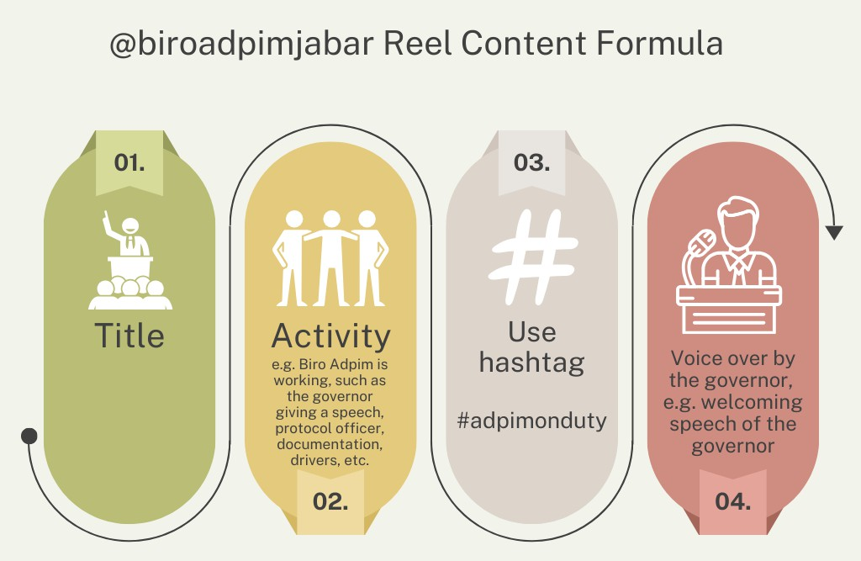

***Figure 6.*** *@biroadpimjabar Reel Content Formula source:* [*www.instagram.com/biroadpimjabar*](http://www.instagram.com/biroadpimjabar)

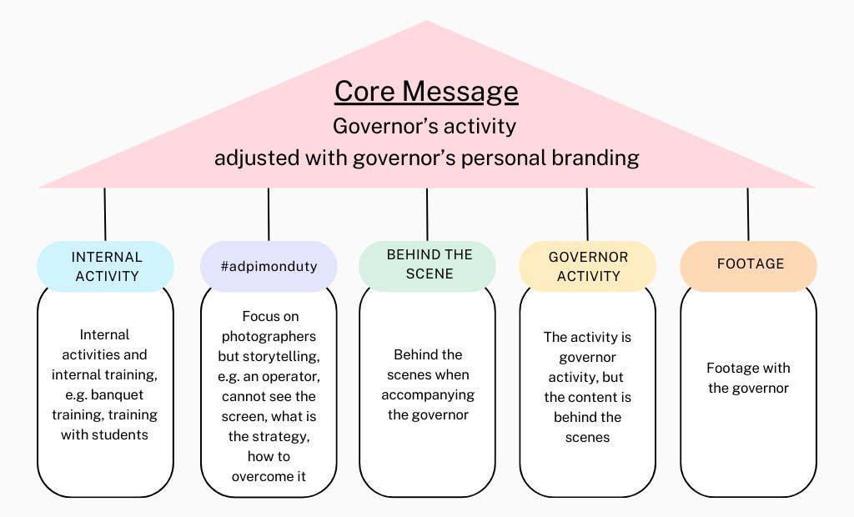The content pillar is the main guideline for determining the narrative angle of the content. The West Java Leadership Administration Bureau decided that the content pillar should focus on leadership activities. Then, this foundation was reduced to five content pillars, which became the guidance for the West Java Leadership Administration Bureau, as depicted in Figure 7 and Figure 8 for the implementation.

***Figure 7.*** *@biroadpimjabar Content Pillar*

The existence of content pillars that the Bureau of Leadership Administration has prepared facilitates the distribution of leadership content that the Public Relations account or the Bureau of Leadership Administration account must upload. In other words, the content on Instagram @biroadpimjabar can be a backup for content uploaded by Public Relations related to the leadership. Based on the interview results, the @biroadpimjabar account makes it easier for public relations to distinguish which leadership activity content must only be uploaded to the @biroadpimjabar and public relations accounts.

|  |  |
| --- | --- |
|  |  |
| (a) | (b) |
|  |  |
| (c) | (d) |
|  | |
| (e) |  |

***Figure 8****. Content Pillar Implementation of @biroadpimjabar: Internal Activity (a), #adpimonduty (b), Behind The Scene (c), Governor Activity (d), Footage (e) Source:* [*www.instagram.com/biroadpimjabar*](http://www.instagram.com/biroadpimjabar)

At the optimization stage, three essential things must be considered: listening, learning, and taking part in authenticity. When information is shared on social media, the public who consumes it will react, whether it is a reasonable reaction. Therefore, an agency must be involved because the subject must listen to what the public is talking about them and must learn to improve what is lacking in the information or messages conveyed through social media. The West Java Leadership Administration Bureau knows what its public is talking about by using the Instagram feature, namely through messages that come into direct messages (DM).

One of the optimizations of Instagram usage carried out by @biroadpimjabar is producing content daily based on the dynamics of the leader's activities. Consistency in uploading posts will have a greater chance of remaining visible on @biroadpimjabar followers'. Their message strategy was informative but still exciting and adjusted to followers' preferences. They use relevant and visually appealing content, significantly increasing audience interaction. Content containing work-related information from the leader is a form of effort by @biroadpimjabar that can increase audience trust to the West Java Government. Transparent content about how the leaders work could increase positive perceptions and credibility of the West Java Government. Besides, consistent and engaging Instagram content helps audiences understand the work of leaders in the West Java Government. Innovative visuals, authentic stories, and engagement with the audience could increase public awareness.

Optimization of content on @biroadpimjabar follows the personal branding of the leader. In this context, it is the current acting Governor of West Java, Bey Machmudin. Based on the interview results, an example is if the leader does not like the design of the billboard, which usually contains a photo of an official, then the billboard is not designed to include a picture of the official.

The implementation of management can be seen from the ability of the @biroadpimjabar account team to analyze the suitability of their content with the audience. This is done by first conducting social media monitoring of the @biroadpimjabar Instagram account. Social media monitoring is carried out to evaluate feeds, reach, followers' activity, interaction, attractiveness, engagement, likes, comments, and shares. In addition to using Instagram Insight, they also use third-party applications. In the management stage, social media monitoring is carried out so that the content strategy presented by @biroadpimjabar remains relevant to the audience. From social media monitoring, it can be seen which content is compelling and which is not. If ineffective content is found, @biroadpimjabar will conduct periodic evaluations and adjust the content treatment. Such as following the latest trends but still within the corridor of the leader's branding.

Based on the results of the interview with the Administration Bureau of the Leadership of the West Java Provincial Secretariat, the consideration in managing the Instagram content @biroadpimjabar is whether or not the leadership is pleased. He stated that although the publication management of the previous period was good if it did not match the current acting Governor's branding, it would become a problem for the leadership.

The management process in managing Instagram @biroadpimjabar is also based on the principles of communication management, namely planning, organizing, actuating, and controlling. In planning, the Administration Bureau of the Leadership of the West Java Province analyzes the situation first by analyzing the challenges of building this account.

"Disadvantaged because of the name, but they need the public to know them to make their work easier because their main task is to serve the Governor. So when they introduce themselves, they use the word governor's protocol, not Adpim (Administration of the Leadership)." (Interview With Biro Adpim Team, Asri, 2024)

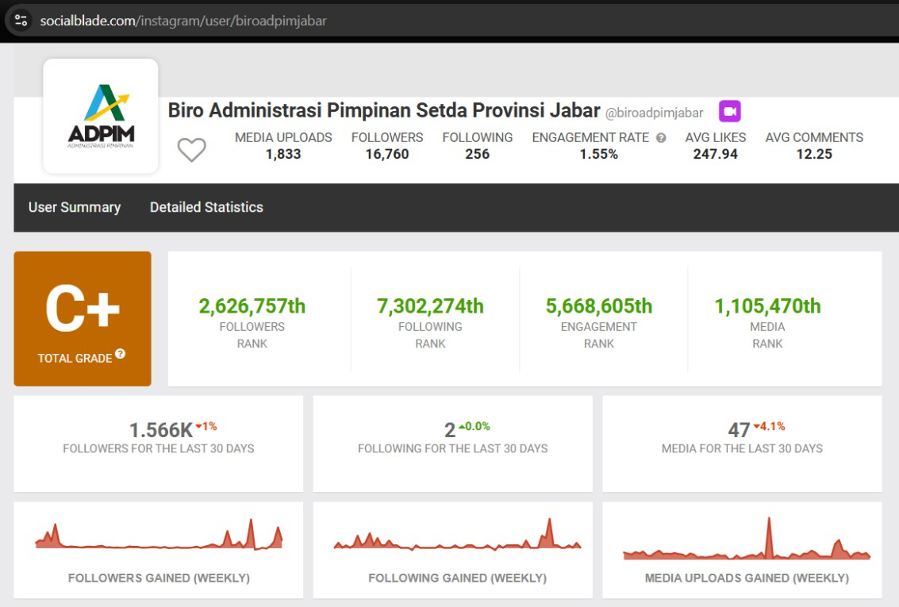Based on the interview results, the Administration Bureau of Leadership is fully aware that it faces challenges in terms of the name. It must use the term "Biro Administrasi Pimpinan," which is abbreviated as "Adpim." Meanwhile, the term "Administration Leadership" sounds less familiar to its target audience, namely the people of West Java.

***Figure 9****. Social Media Monitoring Results @biroadpimjabar Instagram Account Source:* [*www.socialblade.com*](http://www.socialblade.com/)

In this optimize stage, Lutrell re-emphasized three important things that must be done, namely media monitoring, quick response and real-time interaction. The next stage of this optimize concludes that the subject has known what is happening and what is being discussed by the public. These three things have the meaning of how an agency conducts media monitoring, then how an organization interacts in real time and how to respond to the public quickly through social media (Luttrell, 2018).

Media monitoring also carried out by the West Java Leadership Administration Bureau in managing social media in this stage. the way it works is monitoring and evaluating every week with supervision from the West Java Provincial Government Public Relations. The team relies on the Instagram insight feature as a business account user. In addition, it also utilizes third-party applications such as Keyhole and Brand 24.

The Instagram Insight feature itself is very helpful in recapitulating social media in conducting media monitoring because in the features facilitated by Instagram we can see the growth of followers, the age range of followers, the location of followers, to posts that have the most likes and comments. In addition to the insight and business account features, the team also uses monitoring on public posts through tags or marking the Instagram account @biroadpimjabar.

The Engage stage is carried out by the Instagram account @biroadpimjabar, which collaborates with several influencers. @biroadpimjabar chooses influencers who have the same vision, namely informative content. Another reason why informative influencers were chosen is because they are in line with the pillar content created by @biroadpimjabar.

Collaborating with influencers is @biroadpimjabar's way of expanding their reach (Casaló et al., 2020; Pozharliev et al., 2022). One of the influencers they collaborate with is Good Stats (Figure 7a). The Instagram account @biroadpimjabar also increases engagement by inviting interaction with its followers—such as using the CTA (Call for Action) sentence tactic in the caption. In addition, the Instagram account @biroadpimjabar uses hashtags tailored to the content they post. There is no hashtag that they specifically use as the @biroadpimjabar account. For example, if the content is for the West Java Youth Forum 2024, this account will use relevant hashtags such as #JabarCaang, #WestJavaYouthForum, and #WJYF2024.

The thing that needs to be evaluated for the @biroadpimjabar account related to engagement is its lack of presence in the comments column. This account does not try to interact in the comments column.

Based on the interview results, more interactions occur in the direct message feature. The West Java Leadership Administration Bureau stated that more interactions were in direct messages, for example, regarding the audience with the governor.

Optimizing content is also done by creating a sister account. The Acting Governor of West Java is willing to create a new account specifically for activities as governor (Figure 7b). This particular governor account also implements information transparency from the West Java Government (Ball, 2009; Fairbanks et al., 2007; Holland et al., 2018a, 2018b; Moore, 2018; Wood & Aronczyk, 2020).

"Information transparency is seen from the willingness of the new Acting Governor of West Java to create a new social media account specifically as acting governor, apart from his personal Instagram account. The Acting Governor's Instagram account is managed by the governor himself, initially by Adpim." (Interview With Biro Adpim Team, Asri, 2024)

The public relations function should not carry out the agenda-setting theory. It should be based on dialogic and two-way communication (Cheng & Lee, 2023; Men et al., 2018; Wang & Yang, 2020). In other words, the published narrative comes from audience research and is in accordance with the needs of the audience so that interaction occurs, not just informing, as assumed in the agenda-setting theory.

|  |  |
| --- | --- |
|  |  |
| (a) | (b) |

***Figure 10****. Collaboration Content with Good Stats (a), Special Account for Governor Activity (b)*

*Source:* [*www.instagram.com/biroadpimjabar*](http://www.instagram.com/biroadpimjabar)

The high number of direct messages coming into Instagram @adpimjabar made the West Java Leadership Administration Bureau create another service page in the form of Adpim FAQ (Frequently Asked Question) Service to answer questions in direct messages on Instagram @biroadpimjabar. This page is separate from the website in the form of Google Sites.

Based on the interview results, it was said that the communication on the website was very formal. Meanwhile, the communication that occurred in direct messages included reports, logo requests, and how to send letters to Gedung Sate. After a special Google Site was created for FAQs, direct message questions about technical matters decreased.

Collaboration with homeless media, such as Info Sumedang, can help @biroadpimjabar's account get a wider audience. These homeless media have loyal audiences who trust their information. In other words, it can also increase trust in the West Java Government. @biroadpimjabar's account collaborates with homeless media; it is like collaborating with local media and influencers. This is because homeless media is active on Instagram social media and has loyal followers.

Collaboration with homeless media is an increasingly popular strategy. We can think of homeless media as local micro-influencers with followers that match @biroadpimjabar's target audience. Collaboration with homeless media not only increases the awareness of West Java's leaders but can also directly drive trust in the West Java government.

@biroadpimjabar account collaborated with some homeless media to promote the new program of the Governor of West Java to visit the Pakuan Building. The West Java Provincial Government opens the Pakuan Building to the public every Saturday and Sunday. The building has a high historical and educational value that is not yet widely known by the public.

When these homeless media share a positive story about their experience, their followers tend to have more trust to experience what the homeless media did. Besides, influencers who are known among their audiences as trusted news account media in local authorities

This collaboration is seen in the promoting Pakuan Building content. The West Java Provincial Government opens the Pakuan Building to the public every Saturday and Sunday. Acting Governor of West Java Bey Machmudin said the Building has a high historical and educational value that the public has yet to widely know. "We want the public to know that it is a historical building. More or less like the Sate Building. So it is a historical educational tour," said Bey at the State Building, Bandung City.

In the engagement stage, it is emphasized that the subject must pay attention to influencer relations, where the audience is, and how to reach them. In this stage, the West Java Leadership Administration Bureau must understand the target audience so that when choosing an influencer, the subject chooses the right one and can invite or make reasonable changes to the image built by the subject. In this engagement stage, the West Java Leadership Administration Bureau establishes relationships with influencers or influential people. In this case, the influencers chosen are homeless media spread across cities and districts in West Java.

|  |  |
| --- | --- |
|  |  |
| (a) | (b) |

***Figure 11****. Collaboration Content with @infomjlk (a) and @infokuningan (b)*

The evaluation of the public relations function in the Instagram account under the West Java Provincial Government shows good practices. Public relations from the West Java Provincial Government were evaluated using a reward mechanism. Among them are the best FYP content, the best social media account admin, and the best content. The @biroadpimjabar account also conducted sentiment analysis. The evaluation results showed that the average sentiment obtained was neutral to positive.

# CONCLUSION

Instagram account @biroadpimjabar has implemented the circular model of SOME. The results showed that at the Share stage, the shared content of the leader's activities showed transparency so that it could build public trust. In the Optomize stage, the leader uses interesting video content and informative captions. In the Manage stage, a third application is used to monitor the performance of social media to evaluate its activation. The last stage is Engage, for interaction and community involvement in the form of comments and direct messages, even more followers want to conduct audience activities with West Java leaders after learning about the @biroadpimjabar account. These findings provide recommendations for improving public communication strategies to strengthen the implementation of good governance in West Java. However, this account needs to increase engagement by frequently interacting with followers through likes and comments. Although video is the right strategy to increase reach, if the goal is for informative content, there needs to be a variety of content that is not moving.

# REFERENCES

Abdelsalam, H. M., Reddick, C. G., Gamal, S., & Al-shaar, A. (2013). Social media in Egyptian government websites: Presence, usage, and effectiveness. Government Information Quarterly, 30(4), 406–416. https://doi.org/10.1016/j.giq.2013.05.020

Alexander, J. L., Safitri, D., & Anindhita, W. (2022). The Circular Model of Some in Instagram Management (Case Study: Forum Human Capital Indonesia). Jurnal Komunikasi Indonesia, 10(2). https://doi.org/10.7454/jki.v10i2.13882

Armstrong, C. L. (2011). Providing a clearer view: An examination of transparency on local government websites. Government Information Quarterly, 28(1), 11–16. https://doi.org/10.1016/j.giq.2010.07.006

Asri, N. (2024). Wawancara dengan key informant.

Ball, C. (2009). What is transparency? Public Integrity, 11(4), 293–308. https://doi.org/10.2753/PIN1099-9922110400

Bertot, J. C., Jaeger, P. T., & Hansen, D. (2012). The impact of policies on government social media usage: Issues, challenges, and recommendations. Government Information Quarterly, 29(1), 30–40. https://doi.org/10.1016/j.giq.2011.04.004

Biro Adpim Jabar. (2021). Tentang Biro Adpim Jabar. Biroadpim.jabarprov.go.id.

Casaló, L. V., Flavián, C., & Ibáñez-Sánchez, S. (2020). Influencers on Instagram: Antecedents and consequences of opinion leadership. Journal of Business Research, 117, 510–519.

Cheng, I.-H., & Lee, S. T. (2023). Timeliness, responsiveness, and the human voice: The effects of dialogic strategies and the mediating role of perceived communication ethicality on social media relationship building. Public Relations Review, 49(4), 102355. https://doi.org/10.1016/j.pubrev.2023.102355

Dwivedi, Y. K., Rana, N. P., Tajvidi, M., Lal, B., Sahu, G. P., & Gupta, A. (2017). Exploring the role of social media in e-government. Proceedings of the 10th International Conference on Theory and Practice of Electronic Governance, 97–106. https://doi.org/10.1145/3047273.3047374

Edelman Trust Barometer. (2024). Special Analysis: Trust and Government.

Fairbanks, J., Plowman, K. D., & Rawlins, B. L. (2007). Transparency in government communication. Journal of Public Affairs, 7(1), 23–37. https://doi.org/10.1002/pa.245

Hadi, A., Asrori, & Rusman. (2021). Penelitian kualitatif studi fenomenologi, case study, grounded theory, etnografi, biografi. CV. Pena Persada.

Holland, D., Krause, A., Provencher, J., & Seltzer, T. (2018a). Transparency tested: The influence of message features on public perceptions of organizational transparency. Public Relations Review, 44(2), 256–264.

Holland, D., Krause, A., Provencher, J., & Seltzer, T. (2018b). Transparency tested: The influence of message features on public perceptions of organizational transparency. Public Relations Review, 44(2), 256–264. https://doi.org/10.1016/j.pubrev.2017.12.002

Huda, M., & Yunas, N. (2016). The development of e-government system in Indonesia. Jurnal Bina Praja, 08(01), 97–108. https://doi.org/10.21787/JBP.08.2016.97-108

Hutagalung, S. S. (2016). Media sosial, pejabat publik dan good governance. Prosiding: Seminar Nasional Grand Design Reformasi Aparatur Sipil Negara.

Kementerian Dalam Negeri Republik Indonesia. (2019). Permendagri Nomor 56 Tahun 2019 tentang Pedoman Nomenklatur dan Unit Kerja Sekretariat Daerah dan Kabupaten/Kota. www.peraturan.go.id

Lisdawati, Y. (2022). Penggunaan media sosial dalam penyebarluasan informasi program pemerintah di Dinas Komunikasi Informatika Statistik dan Persandian Kabupaten Rokan Hilir Provinsi Riau. Jurnal Teknologi dan Komunikasi Pemerintahan, 4(2), 68–89. https://doi.org/10.33701/jtkp.v4i2.2876

Luttrell, R. (2018). Social media: How to engage, share, and connect. Rowman & Littlefield.

Luttrell, R. (2021). Social media: How to engage, share, and connect (4th ed.). Rowman & Littlefield.

Matheus, R., Faber, R., Ismagilova, E., & Janssen, M. (2023). Digital transparency and the usefulness for open government. International Journal of Information Management, 73, 102690. https://doi.org/10.1016/j.ijinfomgt.2023.102690

Men, L. R., Tsai, W.-H. S., Chen, Z. F., & Ji, Y. G. (2018). Social presence and digital dialogic communication: Engagement lessons from top social CEOs. Journal of Public Relations Research, 30(3), 83–99.

Moore, S. (2018). Towards a sociology of institutional transparency: Openness, deception, and the problem of public trust. Sociology, 52(2), 416–430. https://doi.org/10.1177/0038038516686530

Nainggolan, R. R. E. (2024a). Analisis penggunaan website dan media sosial pemerintah untuk pelayanan publik. Jurnal Teknologi dan Komunikasi Pemerintahan, 6(1), 1–21. https://doi.org/10.33701/jtkp.v6i1.4221

Nainggolan, R. R. E. (2024b). Analisis penggunaan website dan media sosial pemerintah untuk pelayanan publik. Jurnal Teknologi dan Komunikasi Pemerintahan, 6(1), 1–21. https://doi.org/10.33701/jtkp.v6i1.4221

Porumbescu, G. A. (2016). Linking public sector social media and e-government website use to trust in government. Government Information Quarterly, 33(2), 291–304. https://doi.org/10.1016/j.giq.2016.04.006

Pozharliev, R., Rossi, D., & De Angelis, M. (2022). A picture says more than a thousand words: Using consumer neuroscience to study Instagram users’ responses to influencer advertising. Psychology & Marketing, 39(7), 1336–1349.

Qurniawati, E. F., Mardani, P. B., & Wulandari, H. (2024). The circular model of “SOME” on digital public relations management of Universitas Islam Riau. PRofesi Humas, 8(2), 216. https://doi.org/10.24198/prh.v8i2.49088

Rahmanto, A. N. (2022a). Media sosial dan persepsi publik tentang good governance pada pemerintah daerah di Solo Raya. Jurnal Ilmu Komunikasi, 20(1), 88. https://doi.org/10.31315/jik.v20i1.6433

Rahmanto, A. N. (2022b). Media sosial dan persepsi publik tentang good governance pada pemerintah daerah di Solo Raya. Jurnal Ilmu Komunikasi, 20(1), 88. https://doi.org/10.31315/jik.v20i1.6433

Srisathan, W. A., Ketkaew, C., Jantuma, N., & Naruetharadhol, P. (2024). Trust and website conversion in consumer responses to green product purchasing: A new perspective through the lens of innovative website design’s technology integration. Heliyon, 10(1), e23764. https://doi.org/10.1016/j.heliyon.2023.e23764

Sugiyono. (2017). Metode penelitian kuantitatif, kualitatif, dan R&D. CV. Alfabeta.

Sukarno, M., & Winarsih, A. S. (2021). Analisis pelayanan publik berbasis media sosial (Studi Kasus Provinsi Jawa Tengah). Journal of Social Politics and Governance, 3(1), 12–22.

Voorveld, H. A. M., van Noort, G., Muntinga, D. G., & Bronner, F. (2018). Engagement with social media and social media advertising: The differentiating role of platform type. Journal of Advertising, 47(1), 38–54. https://doi.org/10.1080/00913367.2017.1405754

Wang, Y., & Yang, Y. (2020). Dialogic communication on social media: How organizations use Twitter to build dialogic relationships with their publics. Computers in Human Behavior, 104, 106183. https://doi.org/10.1016/j.chb.2019.106183

We Are Social. (2024). Digital 2024 Indonesia.

Wood, T., & Aronczyk, M. (2020). Publicity and transparency. American Behavioral Scientist, 64(11), 1531–1544. https://doi.org/10.1177/0002764220945359

Yuliani, F., Adriadi, R., & Safitra, L. (2020). Media baru dalam pelayanan publik. Commed: Jurnal Komunikasi dan Media, 4(2), 149–157. https://doi.org/10.33884/commed.v4i2.1467